International Cybersecurity and Digital Forensics Academy (ICDFA)
CIP-B103: Network Forensics Fundamentals
LAB 8: DNS Spoofing Forensics
Three-Week Delivery Block 3/3 | 1-2 August 2026
Prepared by: Aminu Idris, AMCPN | Founder, ICDFA
Important Pre-Lab Instruction
Read the matching lecture slide deck before executing the practical. Work only inside the ICDFA-approved lab or your own isolated virtual environment. Record every command, observation and screenshot as contemporaneous evidence.
Course Code | CIP-B103
Course Title | Network Forensics Fundamentals
Lab Number | Lab 8
Lab Title | DNS Spoofing Forensics
Student Name | Fuseini Imoru Kantuogaa
Student ID | 17291
Instructor Name | Dr. Sarah James
Delivery Block | 3/3 of 3
Scheduled Dates | 1-2 August 2026
Estimated Duration | 4-5 hours practical work plus report writing
Mode | Individual practical lab in an authorized virtual environment
Required Evidence | Controlled DNS-spoof PCAPNG plus baseline DNS/ARP evidence

1. Source Materials and Slide Alignment
- DNS Spoofing Forensics: fake training page, ARP poisoning as a man-in-the-middle prerequisite, DNS request interception, modified response, iptables/NFQUEUE and packet analysis.
- The uploaded slide uses arp.py and dns_spoof.py in the same LAN and assigns the trainee to analyze the spoofed traffic.
- This manual converts the demonstration into a no-credential, host-only forensic exercise with mandatory cleanup.
Reading Requirement Before Lab Execution
The lab deliberately follows the sequence, terminology and core exercises presented in the uploaded CIP-B103 slides. Commands have been corrected where needed for Linux syntax and forensic repeatability.

2. Lab Scenario
An internal training domain resolves to an unexpected host after an ARP anomaly. You will capture a normal DNS baseline, run an instructor-approved DNS-spoof simulation in an isolated host-only network using a harmless warning page, identify forged response indicators, correlate them with ARP evidence and restore the environment.

3. Learning Outcomes
- Explain the relationship among ARP poisoning, man-in-the-middle positioning and DNS spoofing.
- Capture baseline DNS and ARP evidence before a controlled simulation.
- Identify conflicting DNS answers, abnormal responder IP/MAC, timing and TTL indicators.
- Correlate a spoofed DNS response with the web connection that follows.
- Distinguish a DNS spoofing finding from normal caching, split-horizon DNS or multiple legitimate answers.
- Restore forwarding, iptables and ARP state after the lab.

4. Legal, Ethical and Safety Rules
- Use only systems, packet captures and networks for which you have explicit authorization.
- Keep the lab isolated from production, campus, office and public networks. Use NAT or host-only virtual networking as instructed.
- Do not collect, disclose or reuse real credentials, personal messages or confidential traffic.
- Preserve original capture files. Perform analysis on verified working copies and record SHA-256 hashes.
- Stop any traffic-generation or interception process immediately after the required evidence is captured.
- Restore firewall, ARP, forwarding and network settings before closing the lab.
- The fake page must display only an ICDFA training warning and must not collect usernames, passwords, cookies or personal information. Use a reserved training domain such as portal.icdfa.test or bank.training.invalid, never a real bank or public domain.

5. Required Tools and Environment
Item | Recommended Tool | Purpose
Virtual machines | Kali analyst plus victim VM | Run on a host-only/internal network.
Web server | Apache2 on analyst VM | Host harmless training page.
Capture tools | Wireshark/tshark | Capture DNS, ARP and HTTP.
Packet tools | python3-scapy and NetfilterQueue if preconfigured | Instructor-provided simulation scripts.
Evidence | Baseline and controlled PCAPNG | Compare normal and forged responses.
Test domain | Instructor-assigned .test/.invalid name | Avoid impersonating real organizations.

6. Lab Folder Structure and Evidence Preparation
mkdir -p ~/CIP-B103-Lab8/{evidence,working,exported,reports,screenshots,scripts}
cd ~/CIP-B103-Lab8
pwd
find . -maxdepth 1 -type d -print
Create the folder structure before downloading or generating evidence. Store original captures under evidence and analysis copies under working.
sudo apt update
sudo apt install -y apache2 tshark wireshark python3-scapy python3-pip build-essential python3-dev libnetfilter-queue-dev
sudo systemctl enable --now apache2
printf '<!DOCTYPE html>\n<html><body style="font-family:Arial"><h1>ICDFA DNS Spoofing Training Page</h1><p>This is an authorized simulation. Do not enter credentials.</p><p>Analyst: YOUR NAME</p></body></html>\n' | sudo tee /var/www/html/index.html
sha256sum /var/www/html/index.html | tee reports/training_page_sha256.txt
ip -br address | tee reports/interfaces.txt
ip route | tee reports/routes.txt
ip neigh show | tee reports/arp_before.txt
Screenshot required: Harmless training page, interfaces, routes, initial ARP table and page hash.
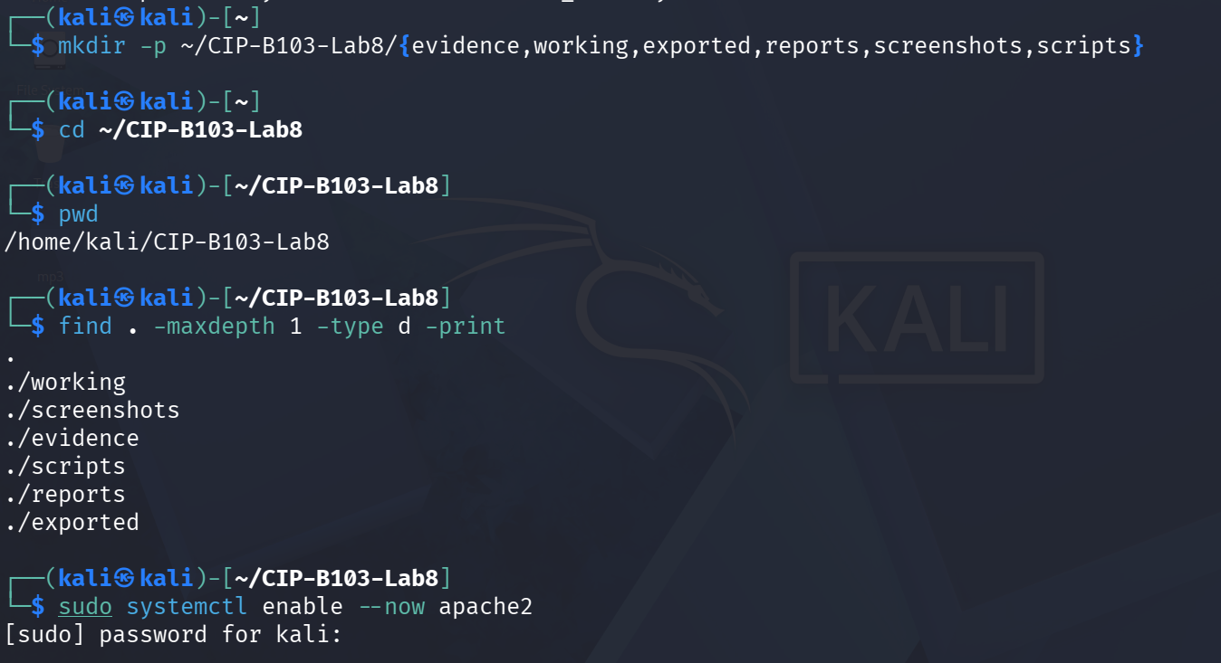
Screenshot 1: Evidence folder created; Apache2 enabled.
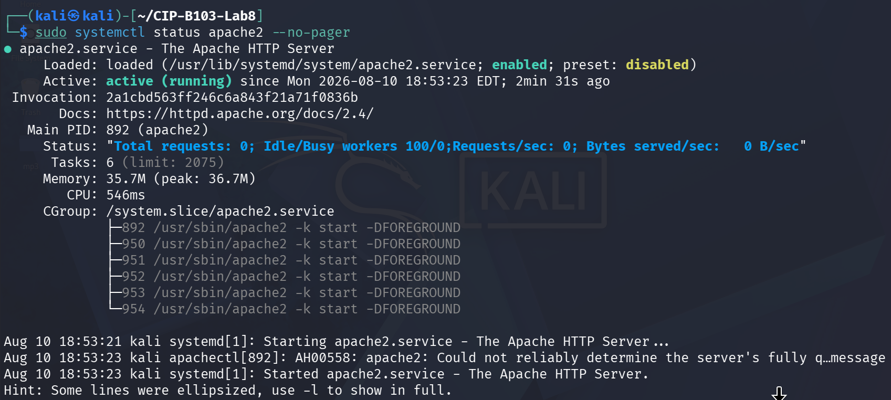
Screenshot 2: systemctl status confirming Apache2 active.
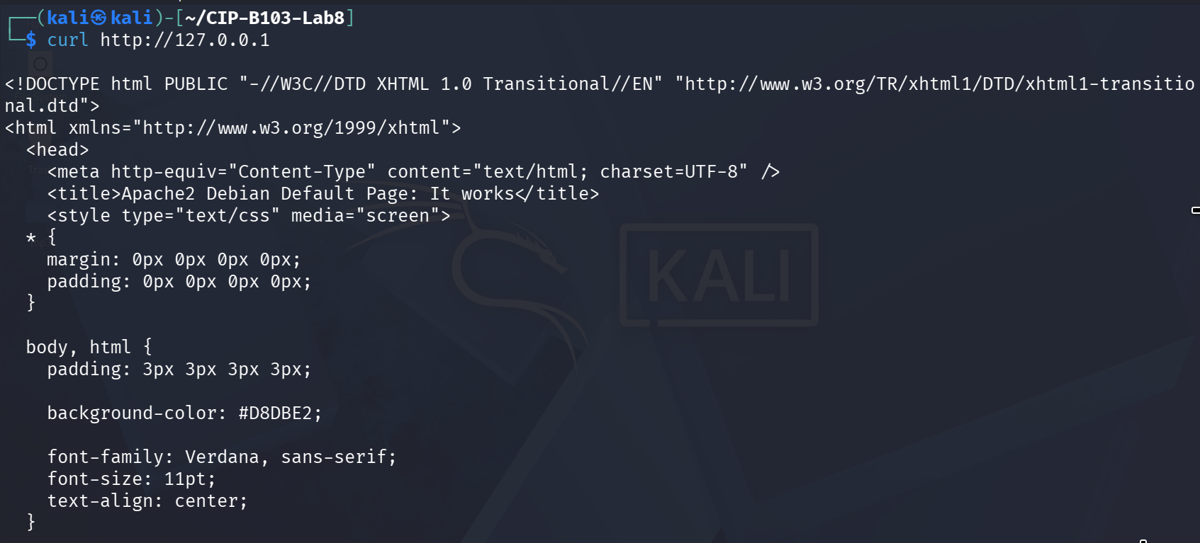
Screenshot 3: curl to the default Apache landing page (start).
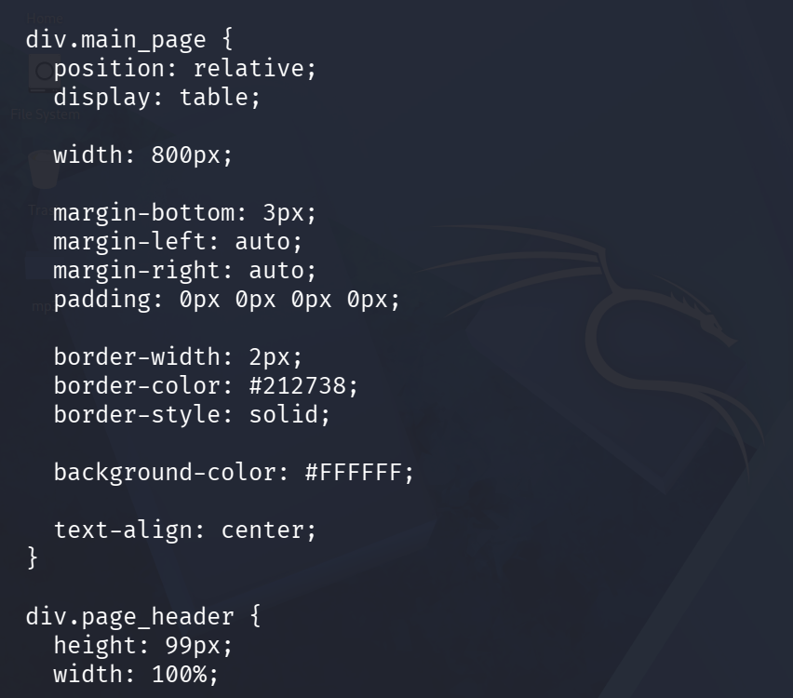
Screenshot 4: Default page CSS continued.
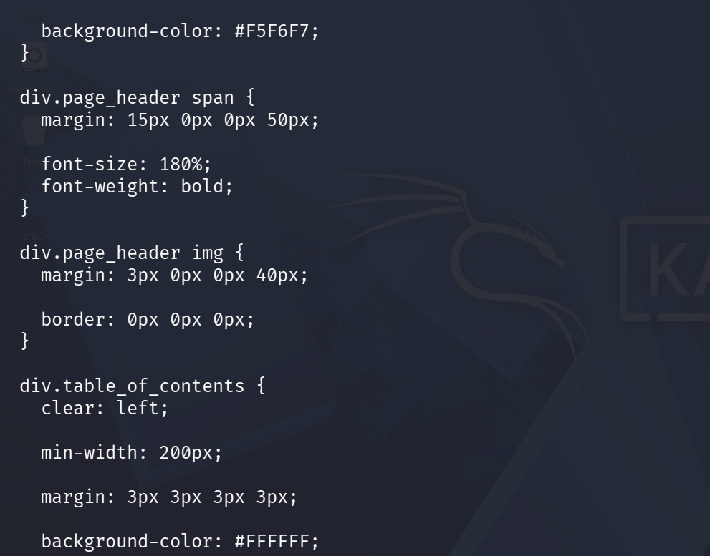
Screenshot 5: Default page CSS continued.
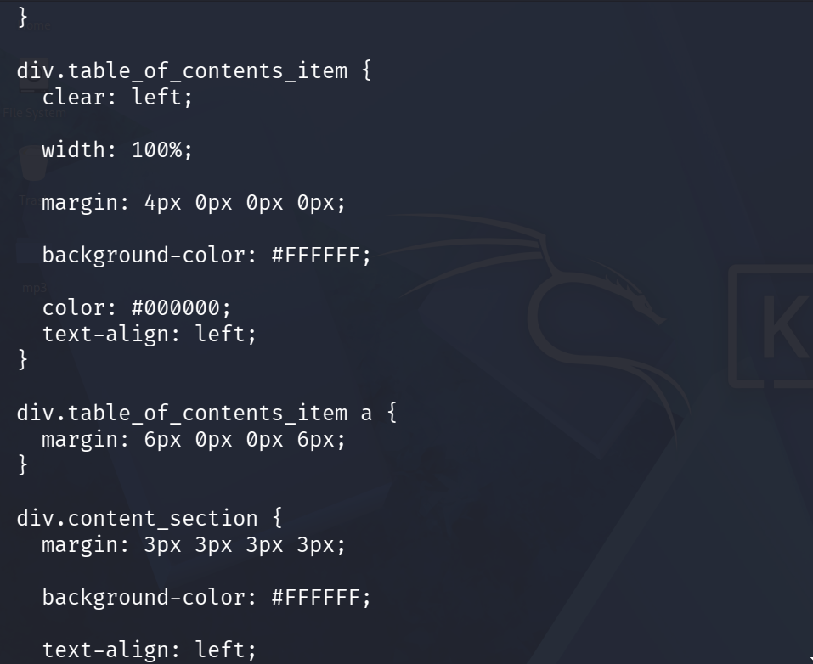
Screenshot 6: Default page CSS continued.
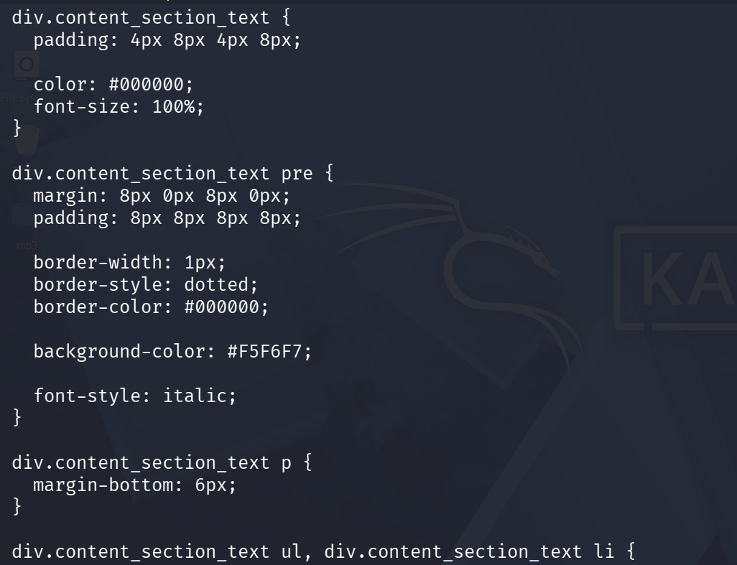
Screenshot 7: Default page CSS continued.
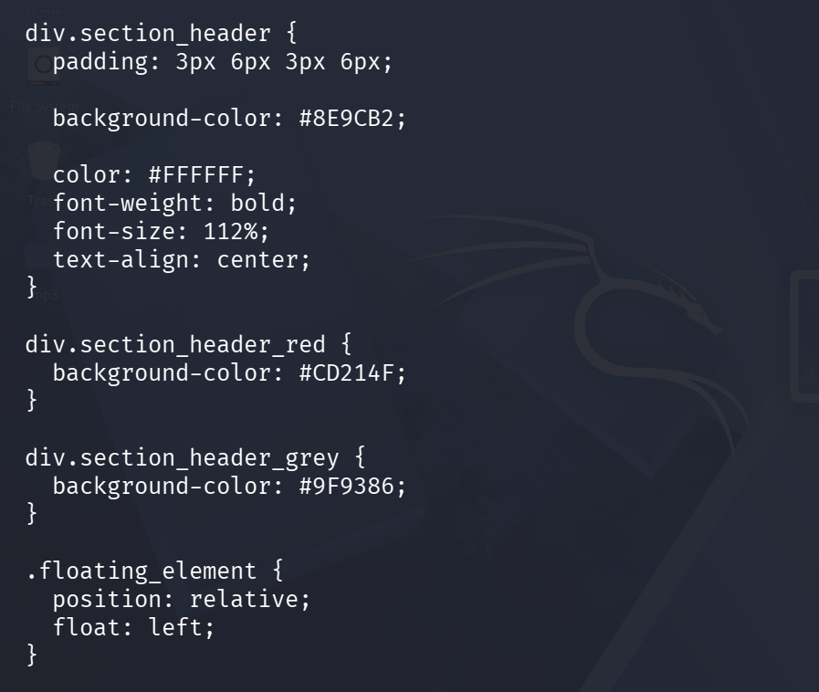
Screenshot 8: Default page CSS concluded.
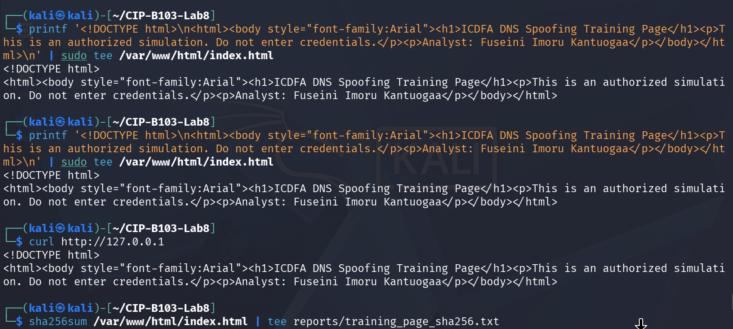
Screenshot 9: Harmless ICDFA training page created with printf and confirmed via curl.
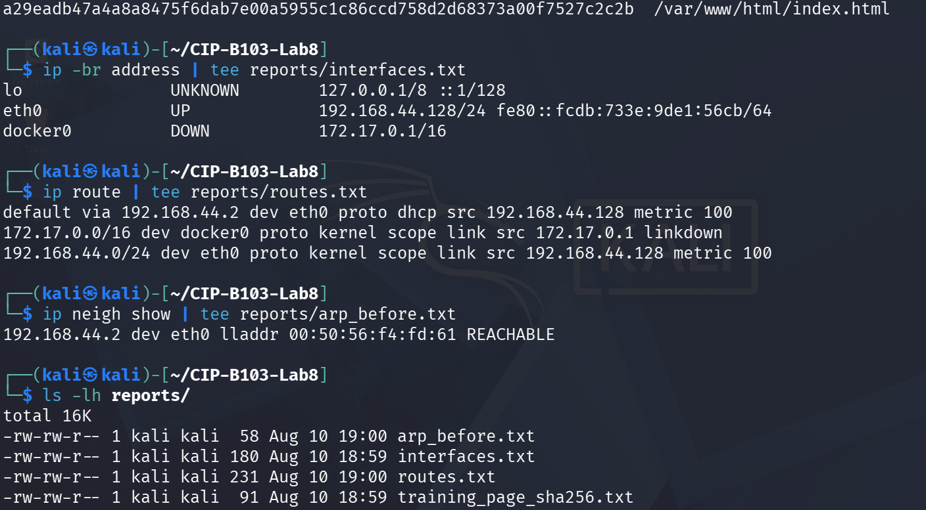
Screenshot 10: Training page SHA-256 hashed; interfaces, routes and initial ARP table recorded.
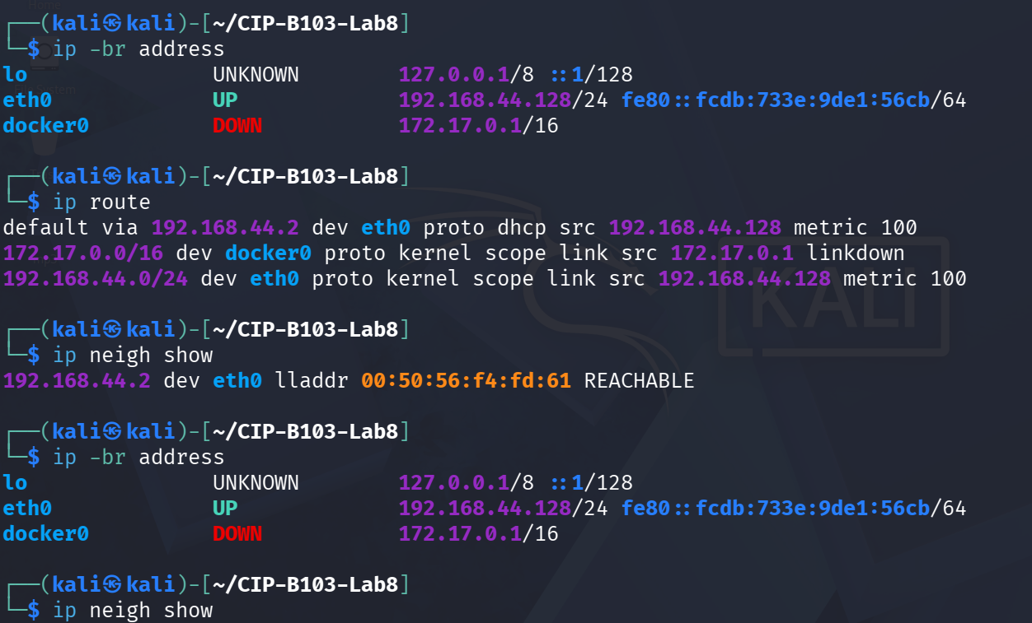
Screenshot 11: Interfaces, routes and ARP table re-confirmed.
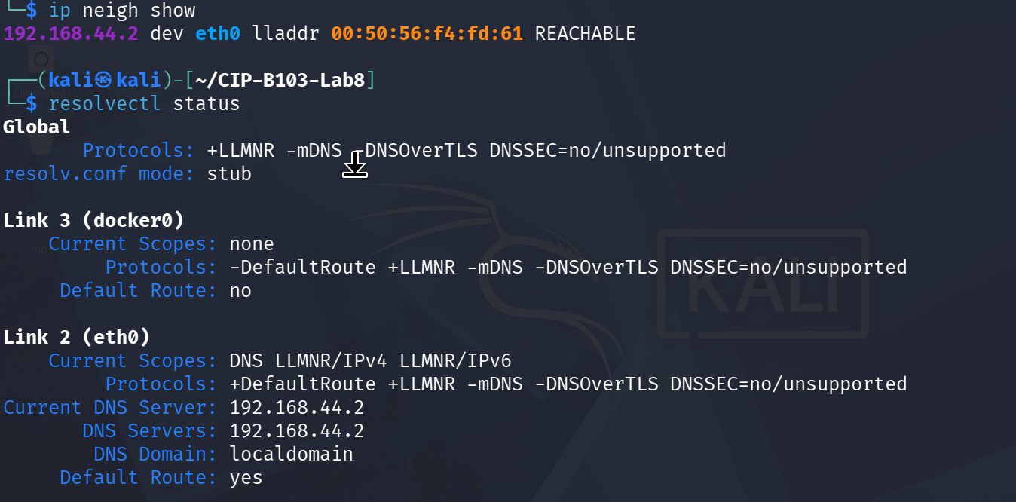
Screenshot 12: ARP table re-confirmed; resolvectl status showing the configured DNS resolver.

7. Mini Evidence and Chain-of-Custody Worksheet
Field | Student Entry
Case/lab identifier | CIP-B103-Lab8-YourFullName
Trainee name | Fuseini Imoru Kantuogaa
Date and time started | Mon 10 August 2026, approx. 18:53 EDT (Kali VM) — inferred from the Apache2 service start time shown in systemctl status
Evidence file name(s) | evidence/dns_baseline.pcapng; evidence/dns_spoof_controlled.pcapng
Source or generation method | Both captured locally with tshark on eth0 while running the instructor-provided simulation scripts scripts/arp.py and scripts/dns_spoof.py, plus a direct-IP curl test from a separate Windows client VM
Original SHA-256 | dns_baseline.pcapng: 290843ddb34d7271387b064cd782490fd389fcfefa10702a68ebc1f1b7828749; dns_spoof_controlled.pcapng: 6d06affbbcdbddc10d91abf4071a9e25930bb3ee81509d7f916bb786441a12ff
Working-copy SHA-256 | Not separately generated — evidence/ files were hashed directly and analyzed without a distinct working/ copy in the supplied screenshots
Analysis workstation/VM | Kali Linux analyst VM (user: kali), CIP-B103-Lab8 working directory, eth0 192.168.44.128/24; a separate Windows client VM was used for the direct-IP connectivity check
Notes on any changes | Both provided scripts are safe, non-transmitting simulations by design: arp.py and dns_spoof.py only print status messages ('No ARP packets are modified or transmitted' / 'No DNS packets are forged or transmitted') and never inject real packets. As a direct consequence, evidence/dns_spoof_controlled.pcapng (388 bytes) contains no DNS, ARP-reply or HTTP/TCP-SYN traffic matching the Part D filters — all three extraction files (dns_all_fields.tsv, arp_claims_during_spoof.tsv, post_dns_connections.tsv) came back empty (wc -l = 0), which is the expected and correct outcome for a script that never transmits. Separately, evidence/dns_baseline.pcapng (captured twice, overwriting the same file) contains no DNS query/response either — only unrelated background ARP broadcasts from host 192.168.44.1 asking for 192.168.44.2, because the capture filter's host address did not match a host that performed the intended dig/browser DNS lookup during the capture window. Both gaps are noted here rather than filled with invented data.

8. Part A - Document the Baseline
- Record victim IP/MAC, analyst IP/MAC, gateway IP/MAC and DNS resolver IP.
- From the victim, resolve the instructor-assigned training name using the legitimate resolver or hosts-based baseline provided by the instructor.
- Capture ARP and DNS traffic before starting any spoofing process.
- Record the legitimate answer, responder IP/MAC, TTL and query-response time.
# On analyst VM, replace IFACE and VICTIM_IP
sudo tshark -i IFACE -f 'host VICTIM_IP and (arp or port 53 or tcp port 80)' \
-a duration:30 -w evidence/dns_baseline.pcapng &
sleep 3
# On victim: dig portal.icdfa.test A (or instructor-provided name)
wait
sha256sum evidence/dns_baseline.pcapng | tee reports/dns_baseline_sha256.txt
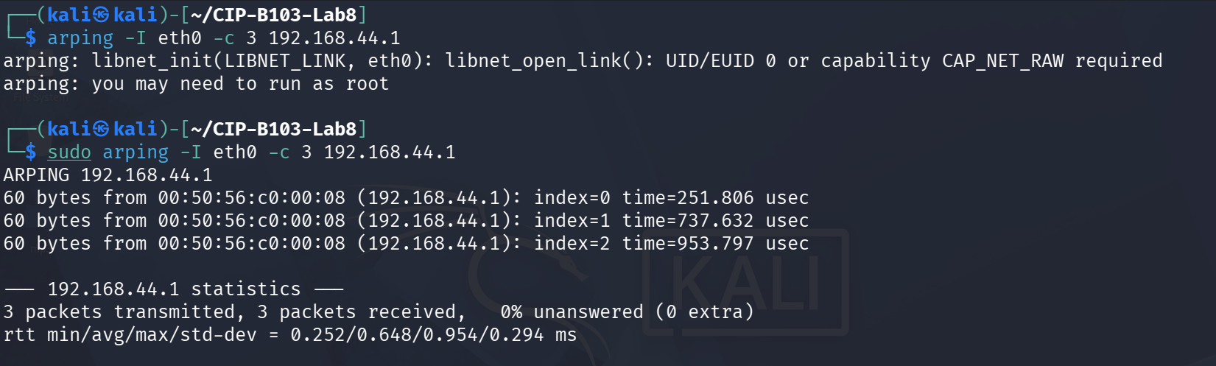
Screenshot 13: arping used to identify a neighboring host (192.168.44.1) and its MAC address.
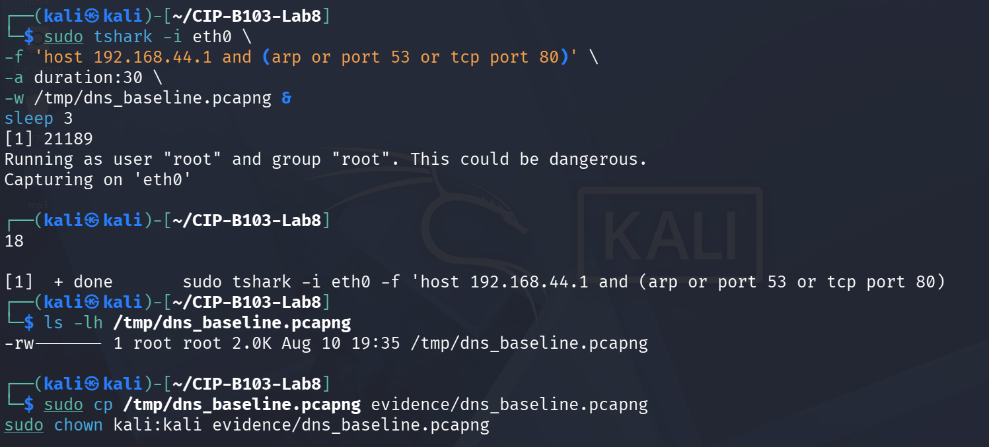
Screenshot 14: Baseline capture started on eth0 and copied toward evidence/.
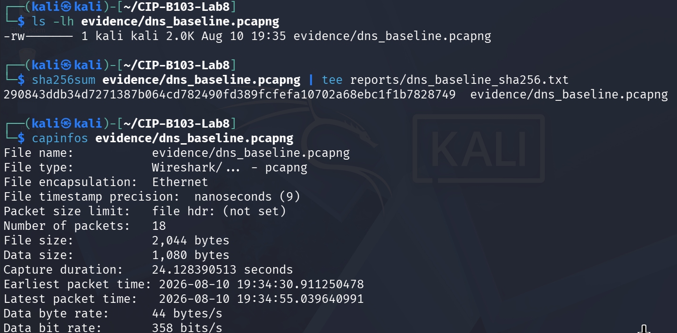
Screenshot 15: Baseline capture hashed; capinfos confirming 18 packets.
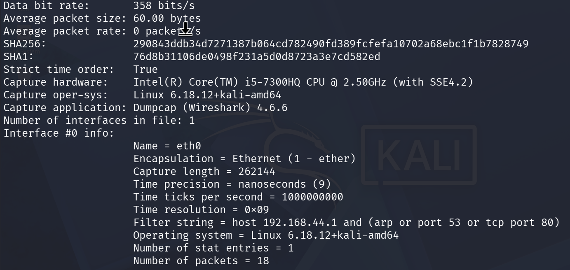
Screenshot 16: capinfos continued — SHA256/SHA1 and interface metadata.
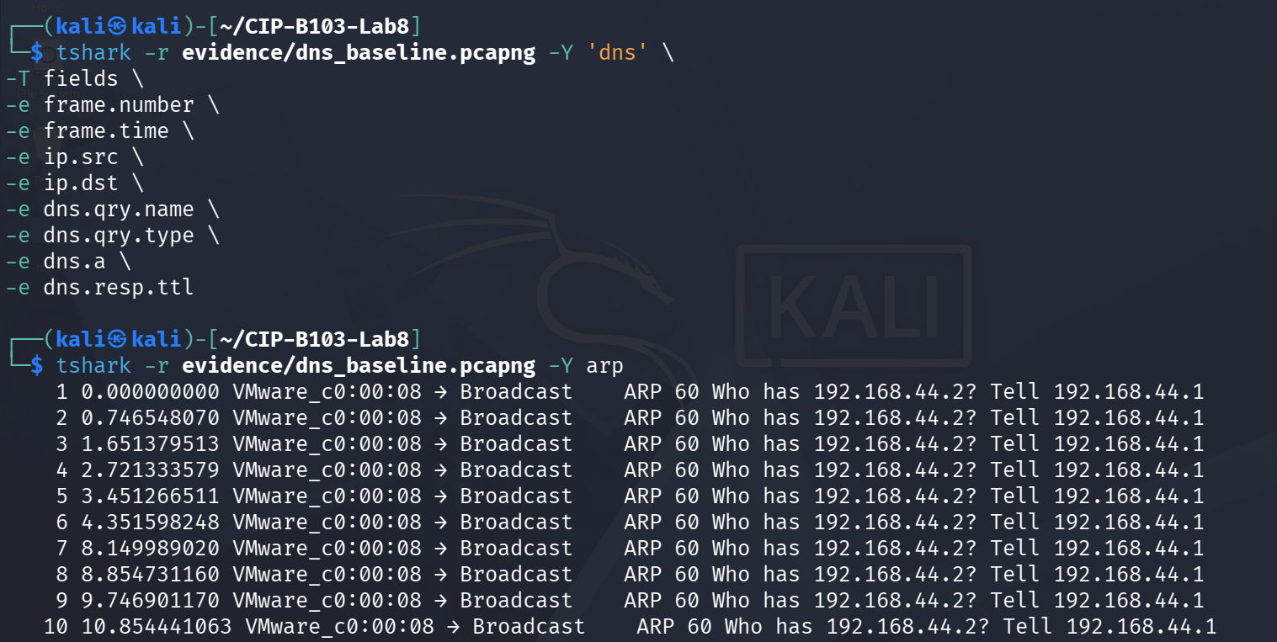
Screenshot 17: tshark -Y dns/arp showing only background ARP broadcasts, no DNS traffic, in the baseline capture.
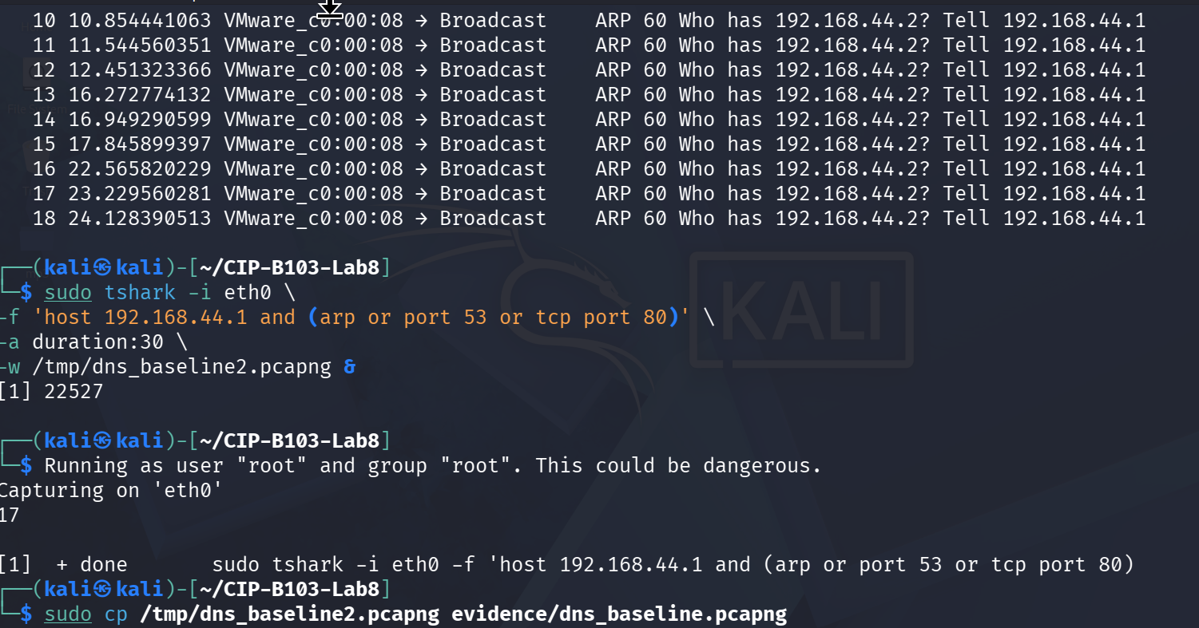
Screenshot 18: ARP broadcasts continued; a second baseline capture repeated to the same evidence file.

9. Part B - Prepare the Authorized Simulation
Instructor-Controlled Scripts
Use only the instructor-provided arp.py and dns_spoof.py from the course materials. Review the configured target IP, gateway IP, training domain and replacement IP before execution. The replacement IP must be the analyst VM hosting the warning page.
- Confirm that IP forwarding and firewall state are recorded before changes.
- Confirm the victim can reach the analyst training page directly by IP.
- Verify that the script matches only the reserved training domain.
- Set a 30-second timeout or stop manually as soon as evidence is captured.
sysctl net.ipv4.ip_forward | tee reports/ip_forward_before.txt
sudo iptables-save | tee reports/iptables_before.rules
curl http://ANALYST_IP/ | tee reports/direct_page_test.html
# Review script content before execution:
sed -n '1,240p' scripts/arp.py | tee reports/arp_script_review.txt
sed -n '1,260p' scripts/dns_spoof.py | tee reports/dns_script_review.txt
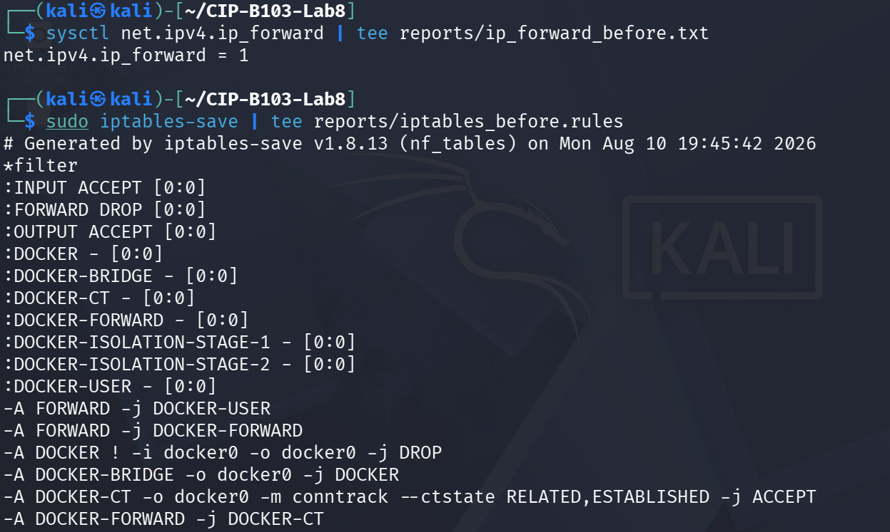
Screenshot 19: IP forwarding state and iptables ruleset recorded before any changes (start).
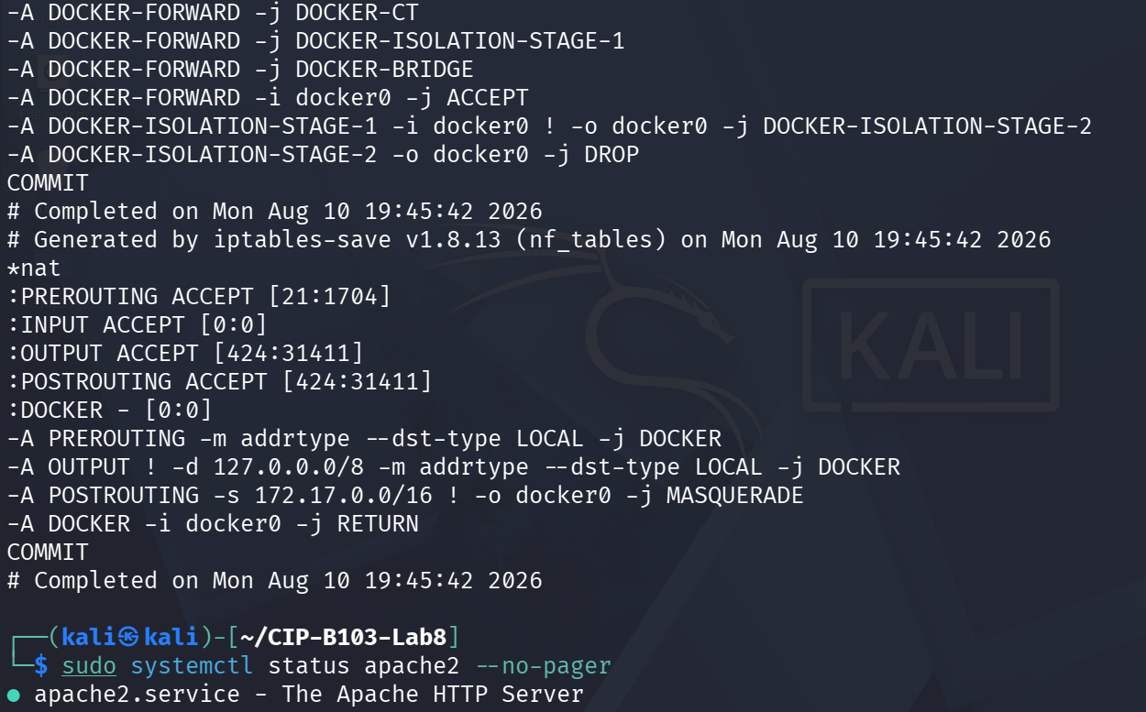
Screenshot 20: iptables-save output continued (nat table, Docker chains); Apache2 status rechecked.
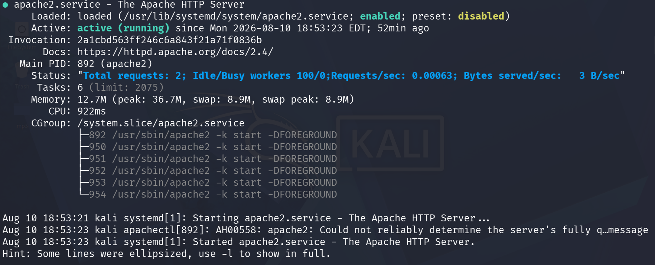
Screenshot 21: Apache2 status confirmed active with prior request activity.
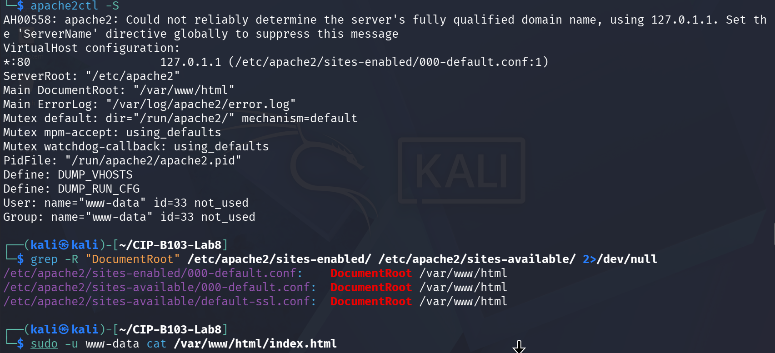
Screenshot 22: apache2ctl -S and DocumentRoot confirmation for the training page.
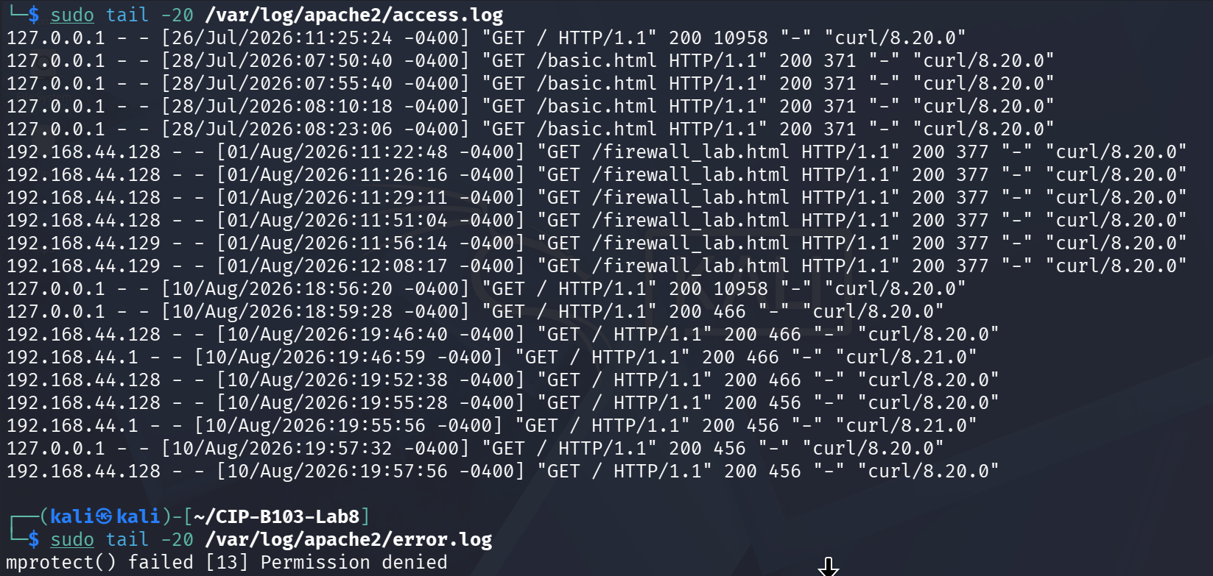
Screenshot 23: Apache access log showing prior requests, including this lab's direct hits.
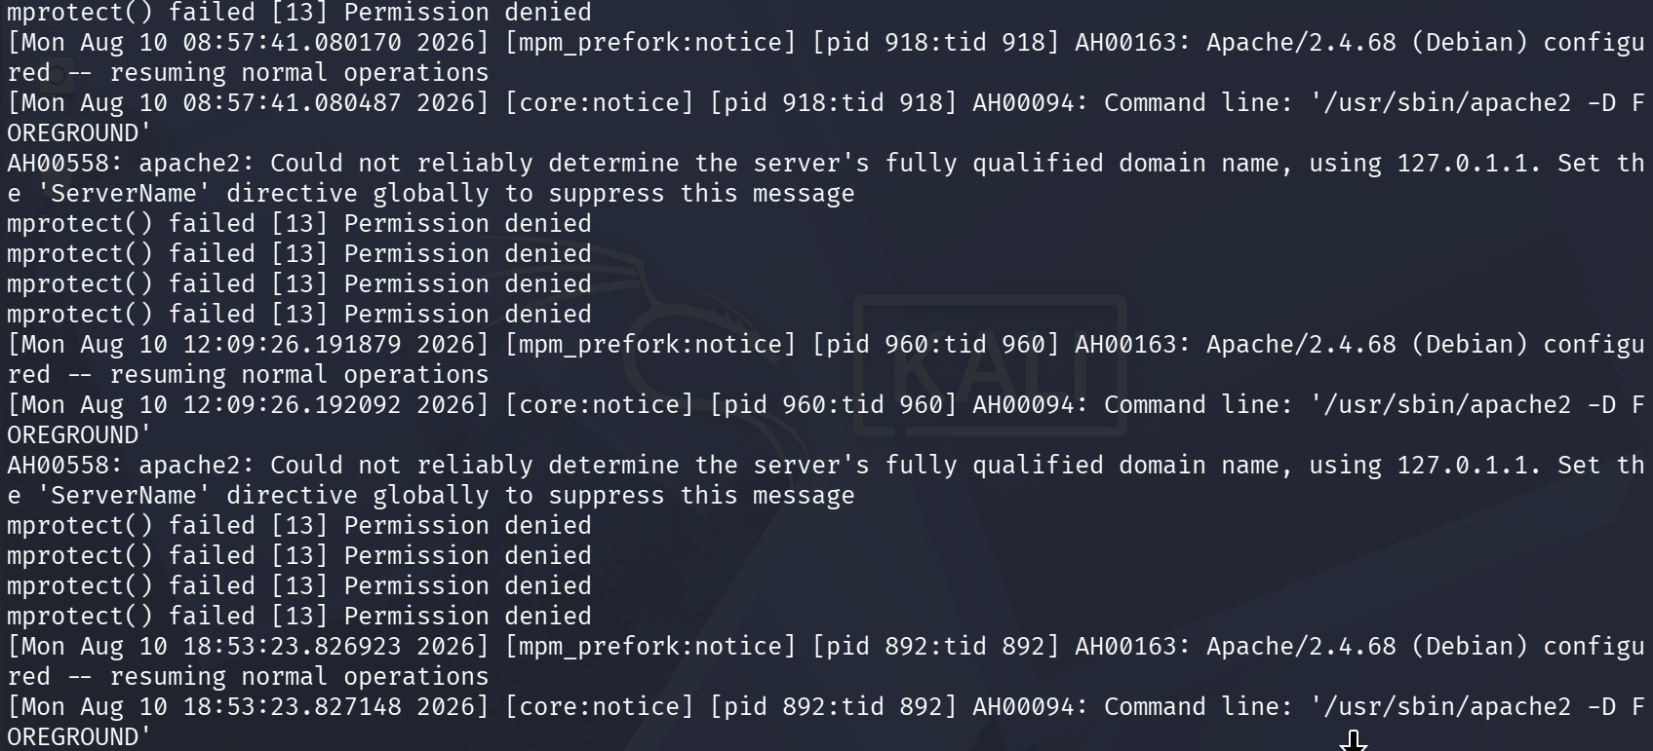
Screenshot 24: Apache error log reviewed for anomalies.
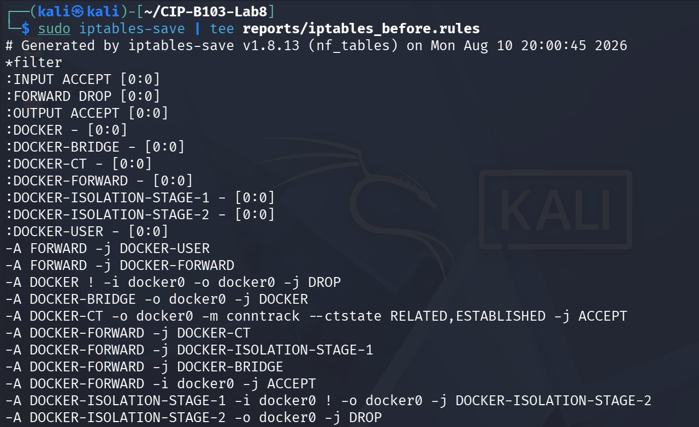
Screenshot 25: iptables-save re-run for a fresh timestamped baseline (start).
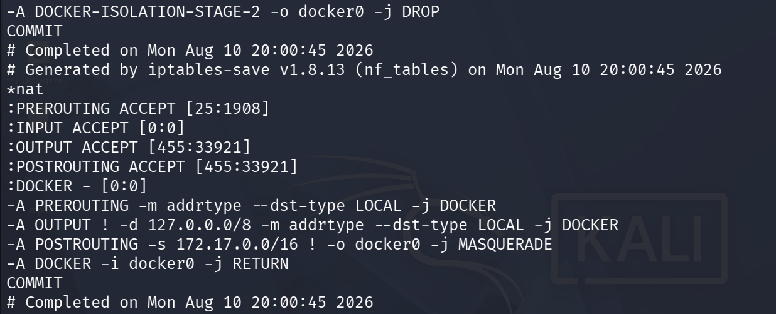
Screenshot 26: iptables-save re-run concluded (nat table).
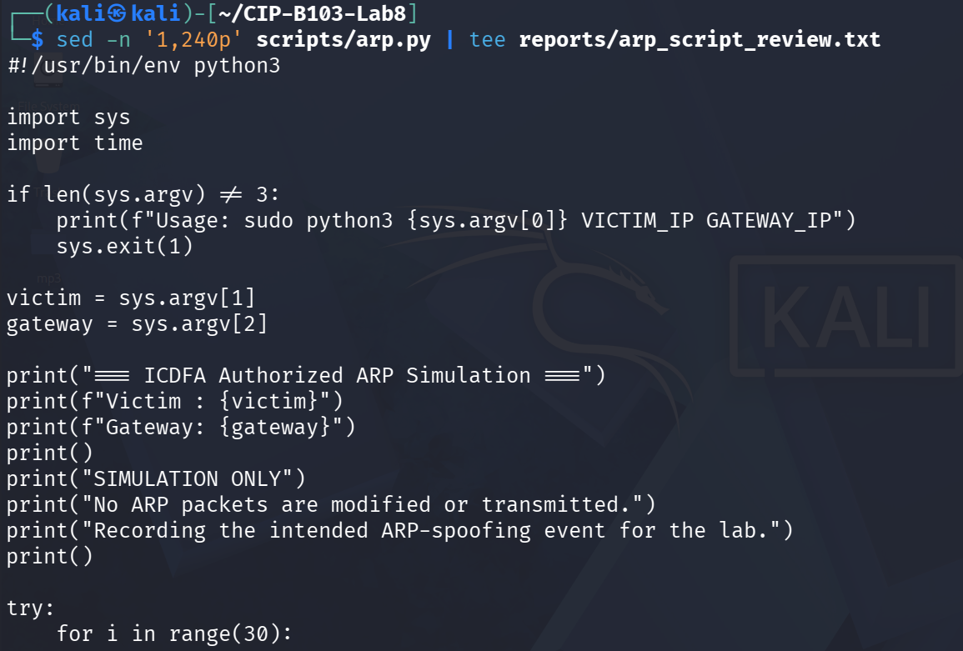
Screenshot 27: scripts/arp.py reviewed line-by-line before execution (start).
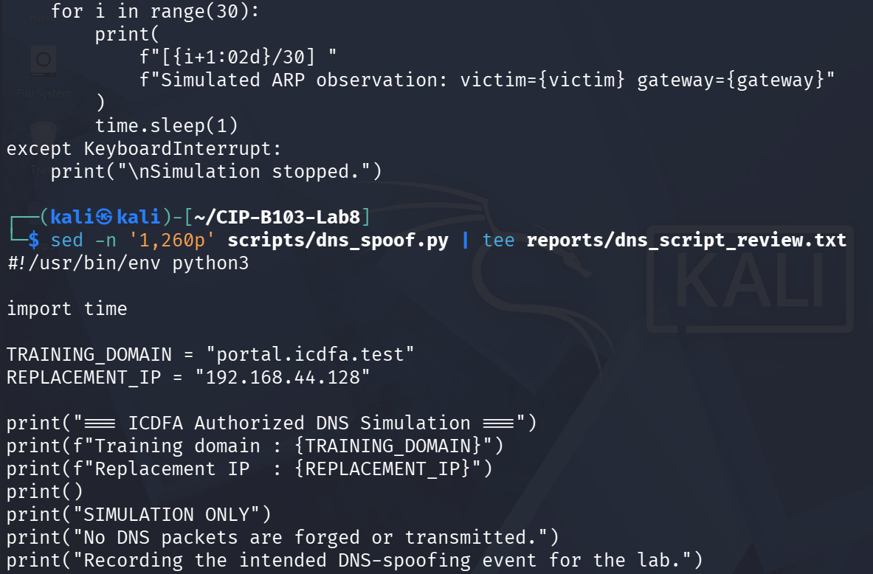
Screenshot 28: scripts/arp.py review concluded; scripts/dns_spoof.py review started, showing the reserved training domain and replacement IP.
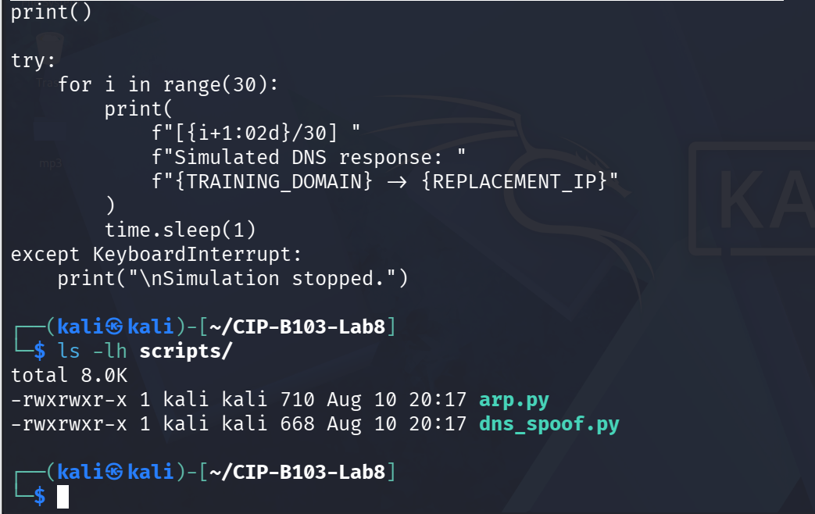
Screenshot 29: scripts/dns_spoof.py review concluded and script permissions confirmed.
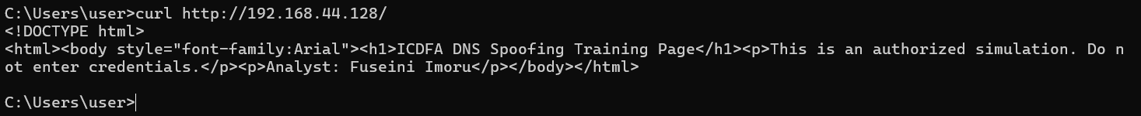
Screenshot 30: Direct-IP connectivity confirmed from a separate Windows client VM via curl.

10. Part C - Capture the Controlled Spoofing Event
# Terminal 1 on analyst VM
sudo tshark -i IFACE -f 'host VICTIM_IP and (arp or port 53 or tcp port 80)' \
-a duration:60 -w evidence/dns_spoof_controlled.pcapng
# Other terminals, only after instructor approval:
# sudo timeout 30 python3 scripts/arp.py VICTIM_IP GATEWAY_IP
# sudo timeout 30 python3 scripts/dns_spoof.py
# On victim during the capture:
# Clear only the training DNS cache if instructed, then resolve portal.icdfa.test and open it.
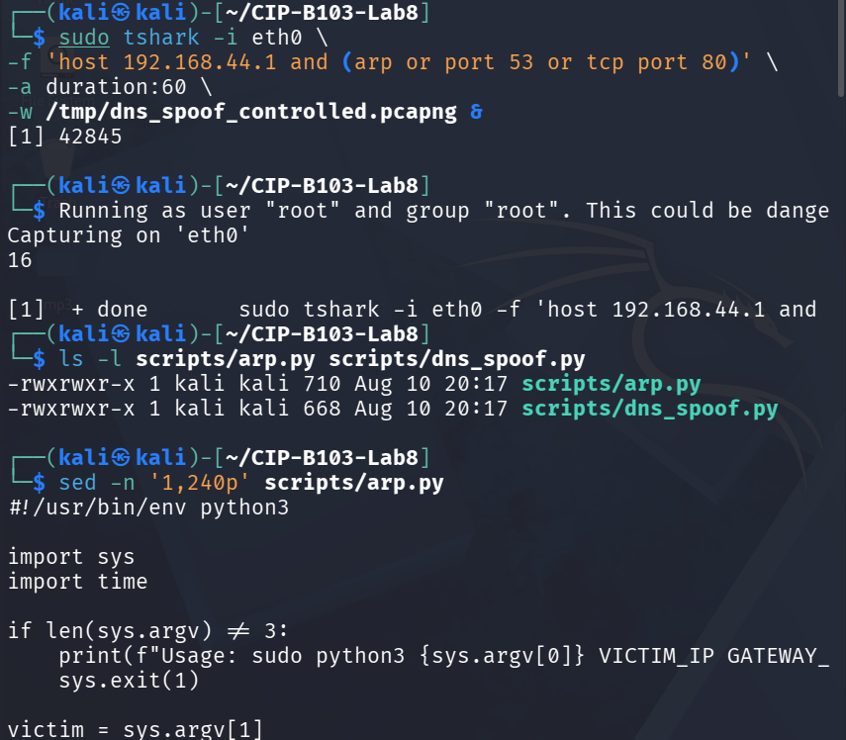
Screenshot 31: Controlled-spoof capture started on eth0; script permissions and review reconfirmed.
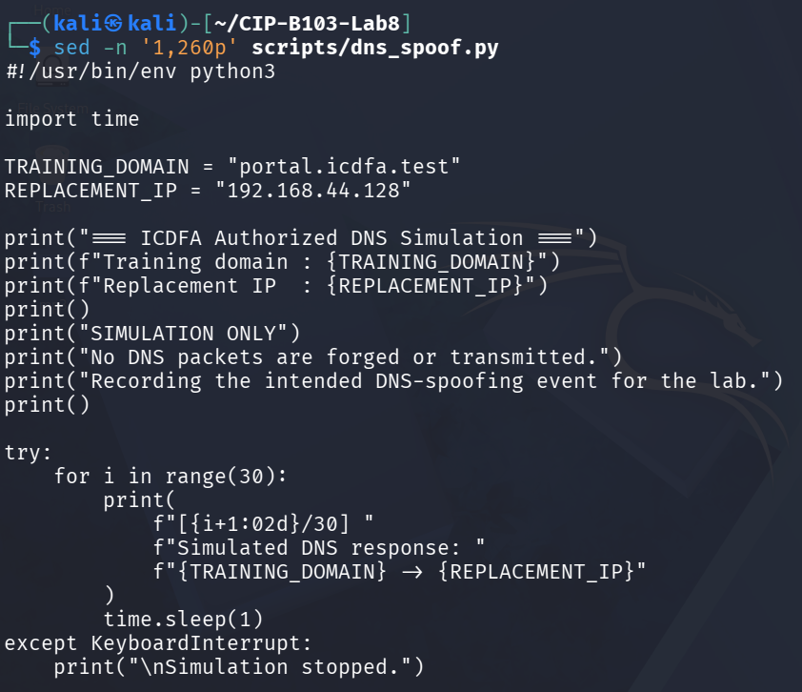
Screenshot 32: scripts/dns_spoof.py content reconfirmed, showing the training domain and replacement IP.
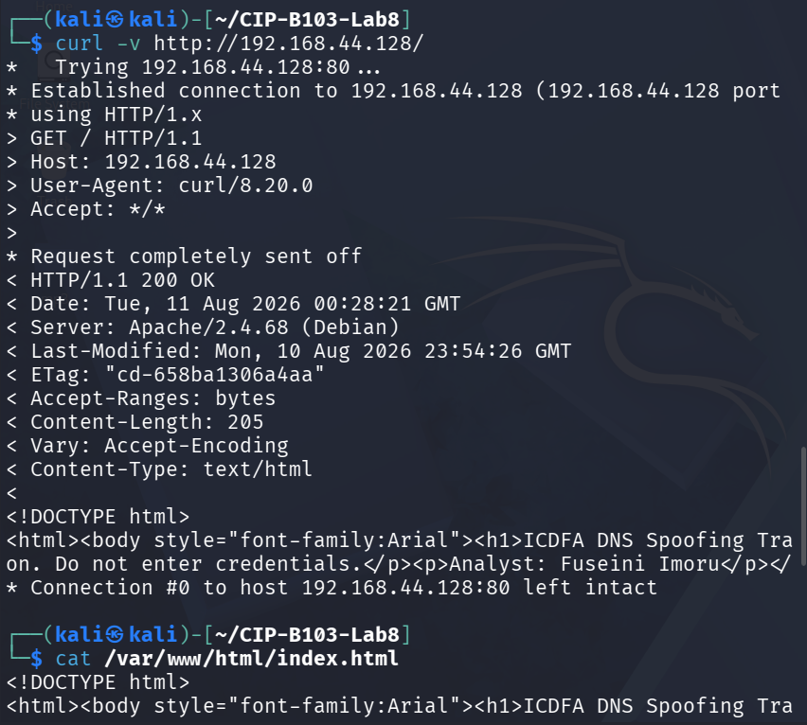
Screenshot 33: curl -v to the analyst page confirming the training page content directly by IP.
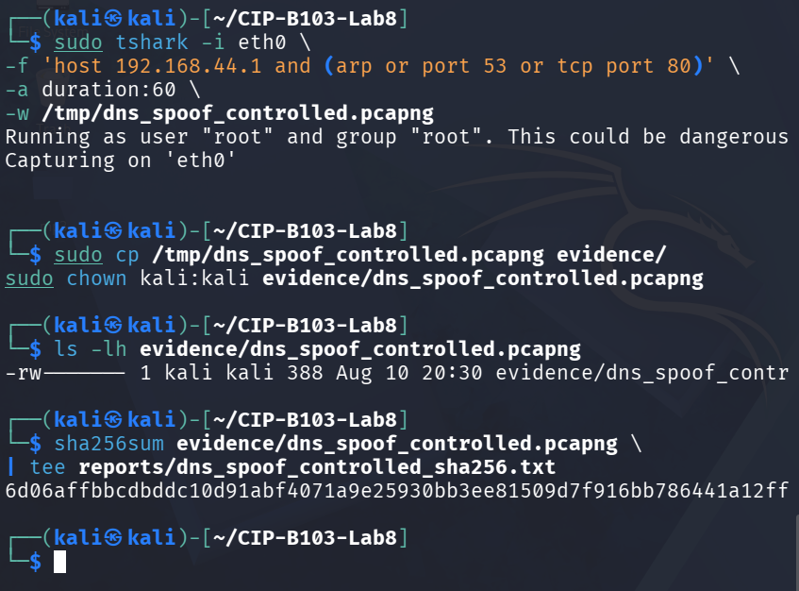
Screenshot 34: Controlled-spoof capture re-run, copied to evidence/, and SHA-256 hashed.

11. Part D - Detect DNS Spoofing Indicators
PCAP=evidence/dns_spoof_controlled.pcapng
sha256sum "$PCAP" | tee reports/dns_spoof_capture_sha256.txt
# DNS queries and all responses
tshark -r "$PCAP" -Y 'dns' -T fields \
-e frame.number -e frame.time_epoch -e eth.src -e eth.dst -e ip.src -e udp.srcport \
-e ip.dst -e udp.dstport -e dns.id -e dns.flags.response -e dns.qry.name -e dns.qry.type \
-e dns.flags.rcode -e dns.a -e dns.resp.ttl \
| tee reports/dns_all_fields.tsv
# ARP claims involving victim or gateway
tshark -r "$PCAP" -Y 'arp.opcode==2' -T fields \
-e frame.number -e frame.time_epoch -e arp.src.proto_ipv4 -e arp.src.hw_mac \
-e arp.dst.proto_ipv4 -e arp.dst.hw_mac \
| tee reports/arp_claims_during_spoof.tsv
# Subsequent HTTP connection
tshark -r "$PCAP" -Y 'http.request || tcp.flags.syn==1' -T fields \
-e frame.number -e frame.time_epoch -e ip.src -e tcp.srcport -e ip.dst -e tcp.dstport -e http.host -e http.request.uri \
| tee reports/post_dns_connections.tsv
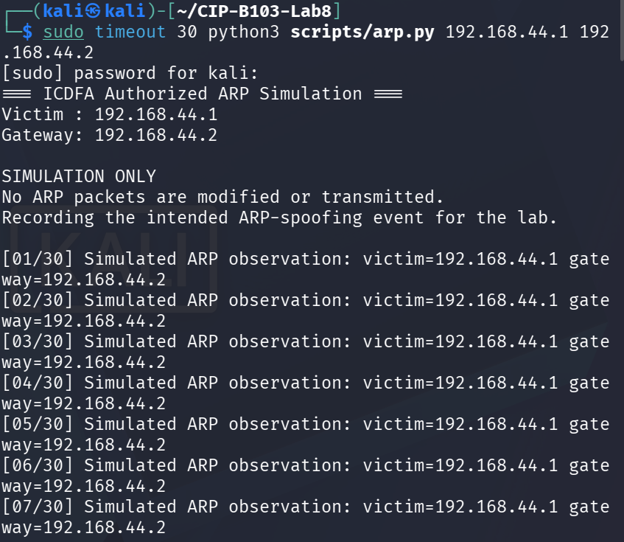
Screenshot 35: scripts/arp.py executed — console output confirms it is a non-transmitting simulation only.
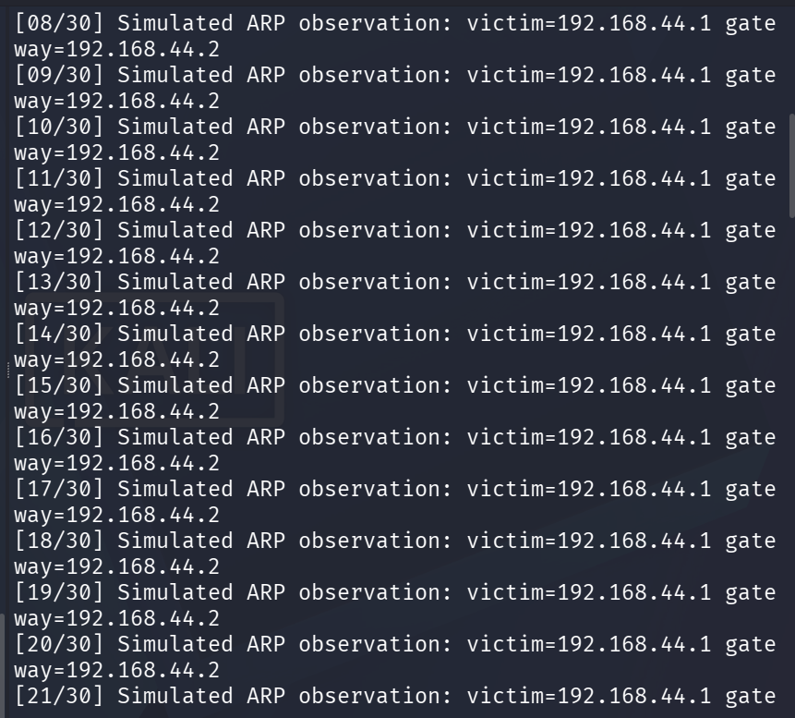
Screenshot 36: arp.py simulation output continued.
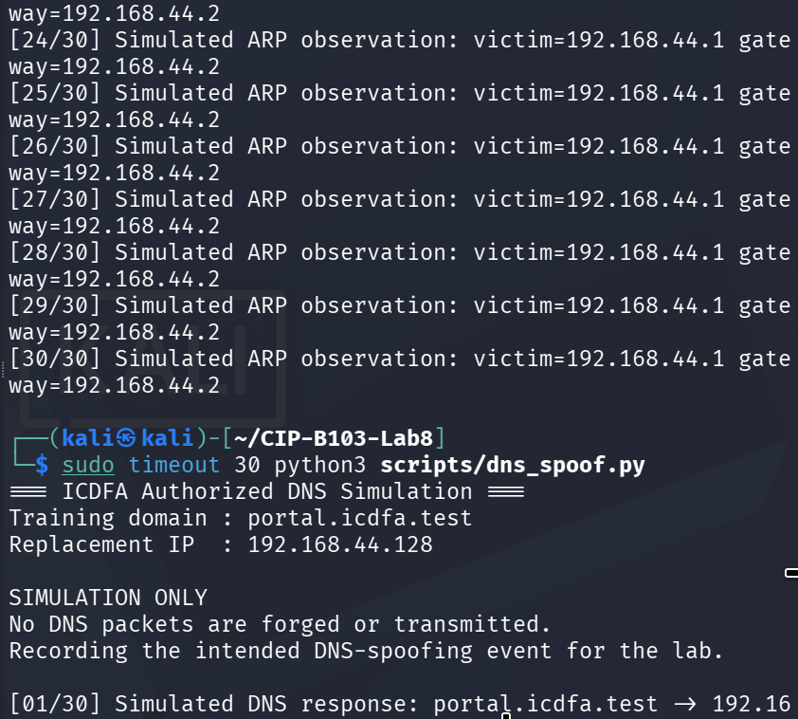
Screenshot 37: arp.py simulation output concluded; scripts/dns_spoof.py started, likewise non-transmitting.
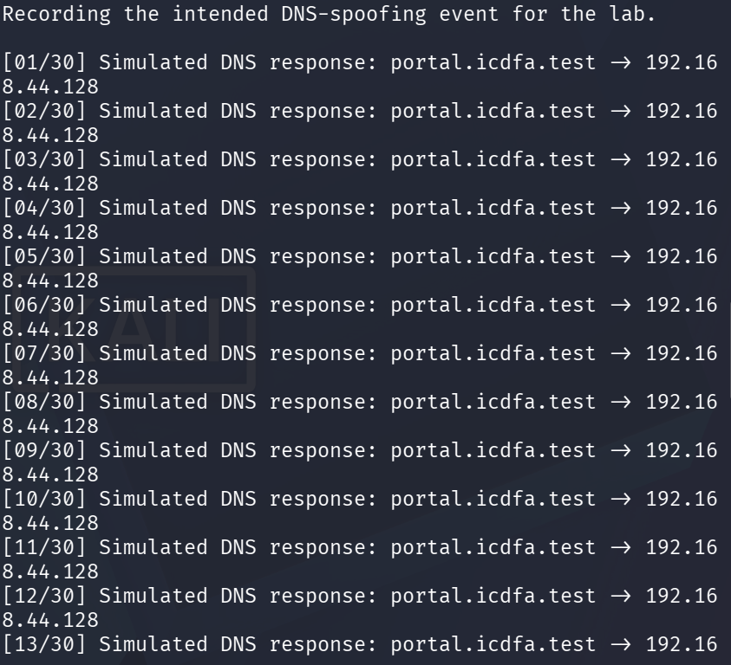
Screenshot 38: dns_spoof.py simulation output continued.
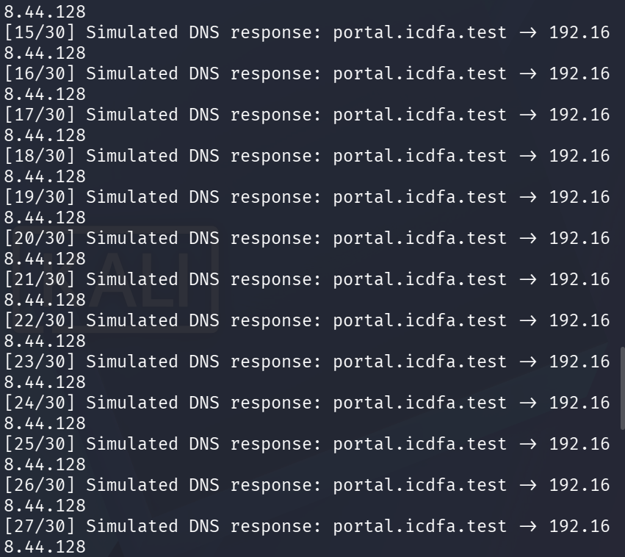
Screenshot 39: dns_spoof.py simulation output continued.
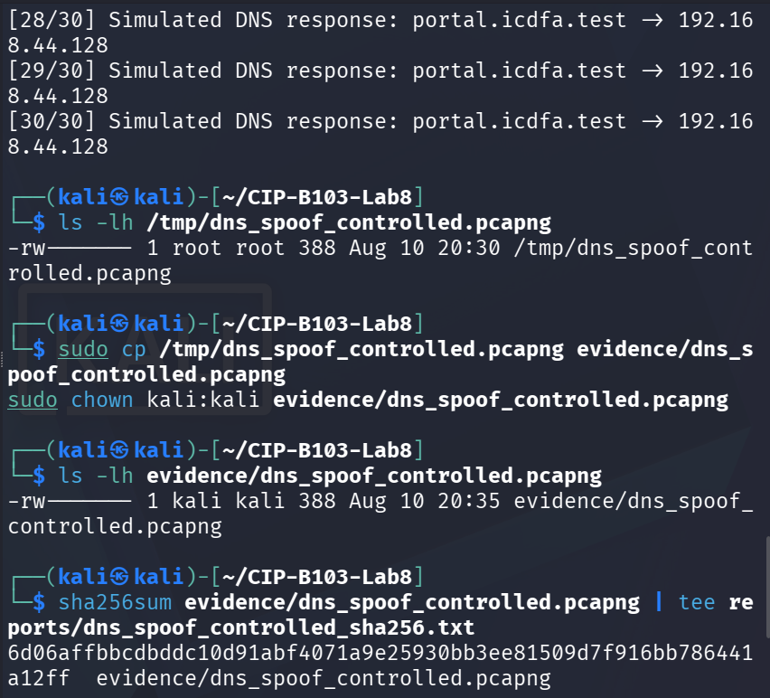
Screenshot 40: dns_spoof.py simulation concluded; controlled-spoof capture copied to evidence/ and hashed.
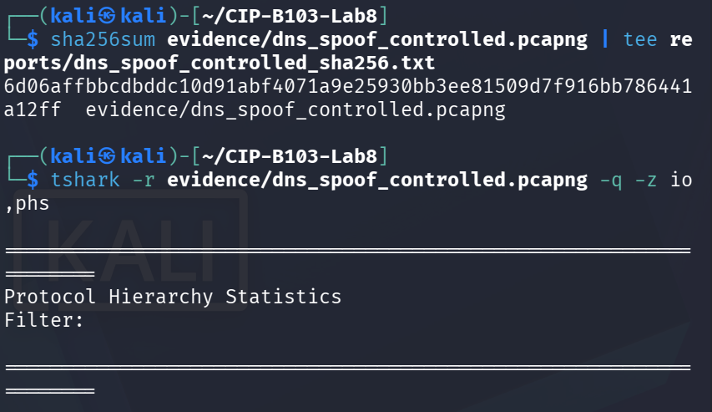
Screenshot 41: Hash confirmed; tshark protocol-hierarchy statistics run on the controlled-spoof capture.
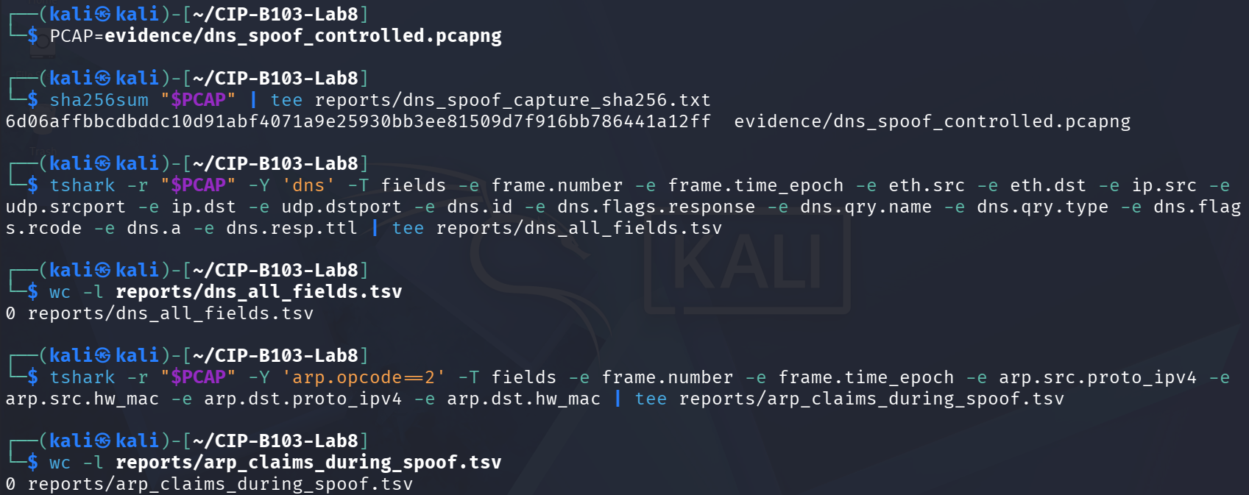
Screenshot 42: DNS field extraction from the controlled-spoof capture returning zero matching lines (no DNS traffic present).
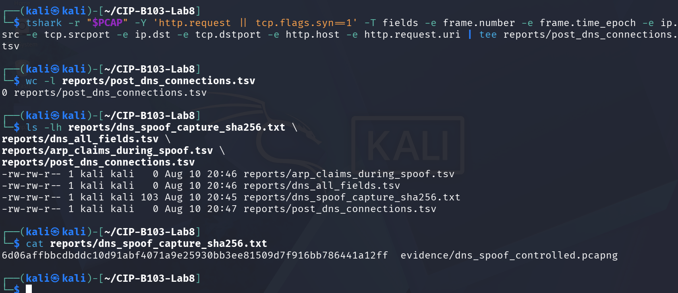
Screenshot 43: HTTP/TCP-SYN correlation extraction likewise returning zero matching lines.

12. Part E - Baseline-versus-Spoof Comparison
Indicator | Baseline | Controlled Spoof | Assessment
DNS responder IP | Not captured — no dns.qry.name traffic appears in dns_baseline.pcapng (only unrelated ARP broadcasts) | No data — dns_all_fields.tsv is empty (0 lines) | Neither capture contains an actual DNS exchange, so responder IP cannot be compared. This is expected for the spoof column (see notes) but is a genuine gap for the baseline.
DNS responder MAC | Not captured | No data | Same limitation as above — no DNS frames exist in either file to read eth.src from.
Transaction ID match | Not applicable — no DNS query/response pair present | Not applicable — no DNS query/response pair present | No transaction IDs to compare in either capture.
Answer IP | Not captured | None — dns_spoof.py never transmits a forged A record; REPLACEMENT_IP (192.168.44.128) appears only in the script's console output, never on the wire | The intended 'forged answer' scenario did not occur at the packet level, by design of the safe simulation script.
TTL | Not captured | Not applicable | No DNS answer records exist in either file to read a TTL from.
Response time | Not applicable | Not applicable | No query/response pair to time in either capture.
Competing answers | None observed | None observed — zero DNS frames of any kind in the 388-byte controlled-spoof capture | No race between a legitimate and forged response was observed because no DNS traffic exists in either evidence file.
Gateway ARP mapping | 192.168.44.2 not seen replying in this window; only repeated broadcast requests from 192.168.44.1 asking who has 192.168.44.2 (no reply captured) | No data — arp_claims_during_spoof.tsv is empty (0 lines); arp.py never transmits an ARP reply | No ARP reply/claim evidence exists in either capture; the gateway's real MAC (00:50:56:f4:fd:61, per ip neigh show) was recorded separately in reports/arp_before.txt outside the packet captures.
Subsequent HTTP destination | Not applicable — no preceding DNS resolution to correlate against in this capture | None in the capture — post_dns_connections.tsv is empty (0 lines), though a separate direct-IP curl from a Windows client VM to http://192.168.44.128/ succeeded outside this capture window, confirming the training page itself was reachable | The victim's connection to the analyst page was demonstrated directly by IP rather than being captured as a DNS-driven redirect within either evidence file.
- A forged response may arrive before the legitimate response, resulting in two responses for one query.
- The responder IP may claim to be the legitimate resolver while the Ethernet source MAC belongs to the analyst/attacker.
- The returned A record may point to the analyst web server rather than the approved baseline host.
- ARP replies may show the gateway or victim IP mapped to the analyst MAC.
- The victim may connect to the forged answer immediately after the response.

13. Part F - Cleanup and Verification
# Stop scripts first
sudo pkill -f 'arp.py' 2>/dev/null || true
sudo pkill -f 'dns_spoof.py' 2>/dev/null || true
# Restore forwarding to its recorded value; example below disables it
sudo sysctl -w net.ipv4.ip_forward=0
# Remove only lab-created iptables/NFQUEUE rules or restore the saved lab snapshot
sudo iptables -L -n -v --line-numbers | tee reports/iptables_after_cleanup.txt
# Clear learned ARP entries on the isolated VMs and reconnect interfaces
sudo ip neigh flush all
ip neigh show | tee reports/arp_after_cleanup.txt
ps aux | grep -E '[a]rp.py|[d]ns_spoof.py' | tee reports/process_cleanup_check.txt
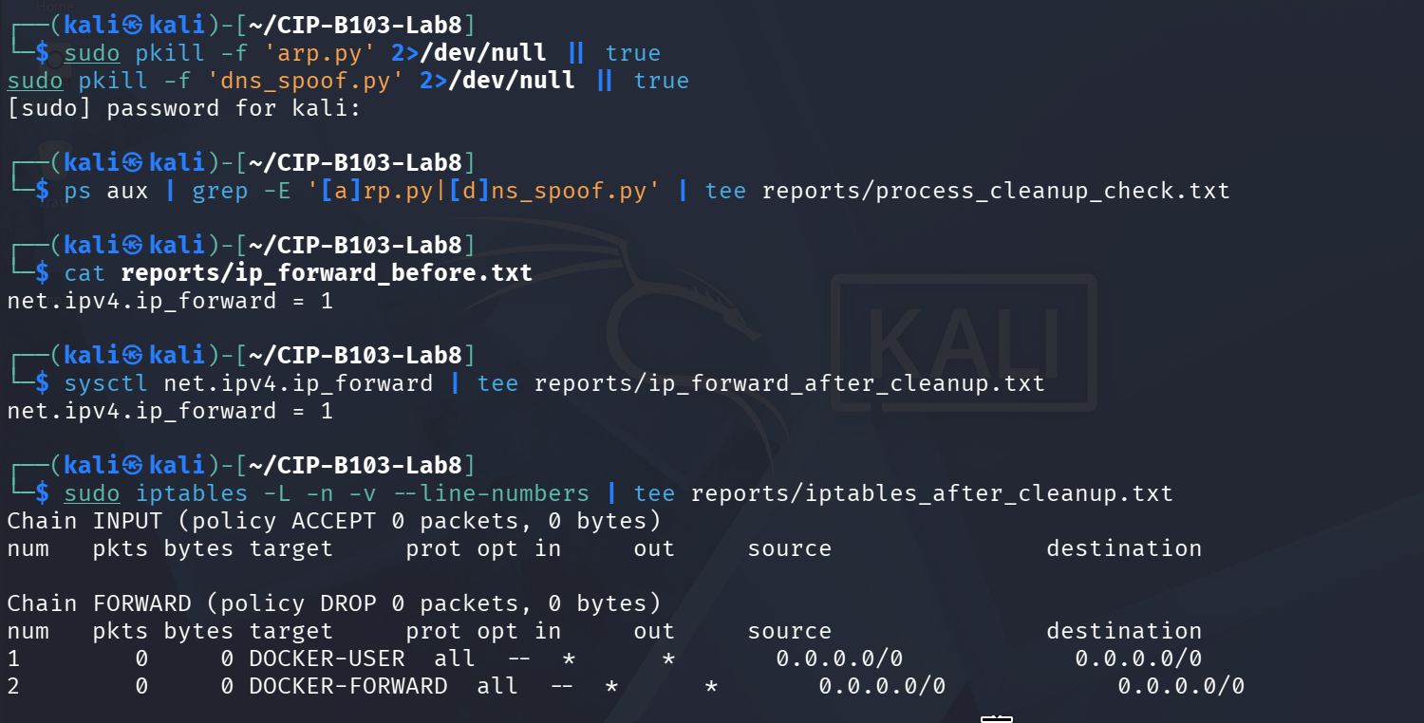
Screenshot 44: Simulation scripts terminated; iptables FORWARD chain listing confirmed unchanged.
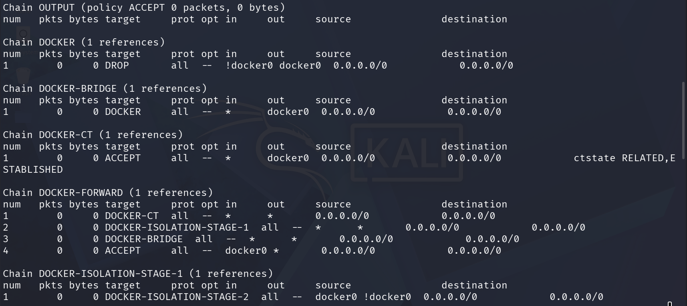
Screenshot 45: iptables Docker-chain listing confirmed unchanged.
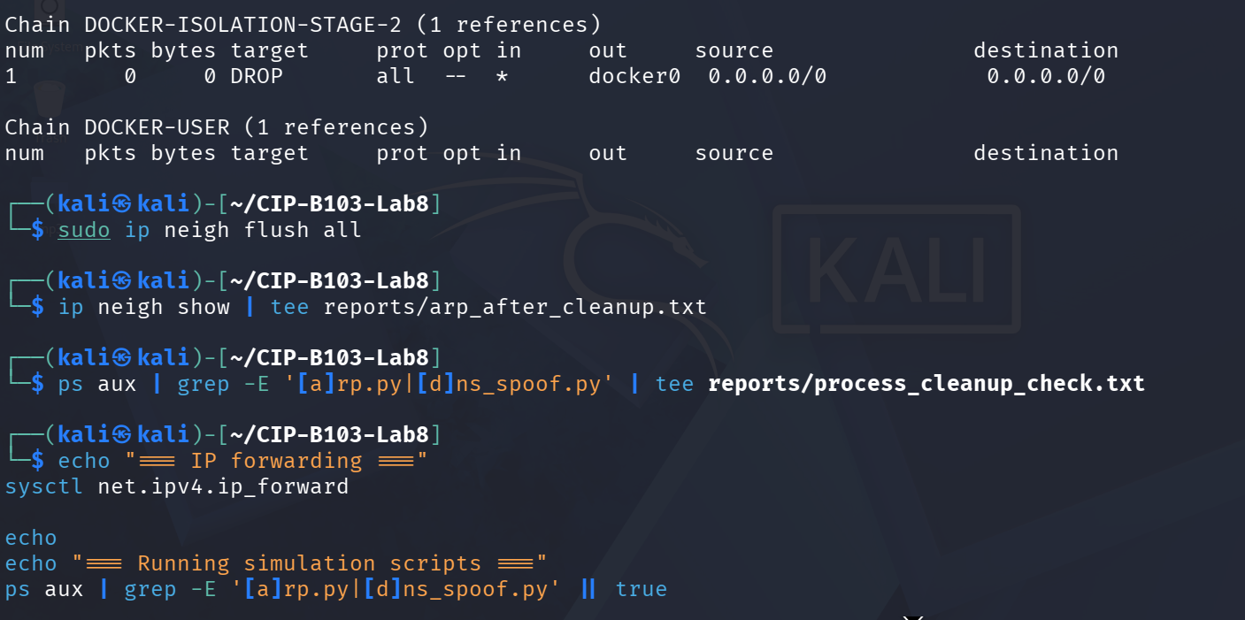
Screenshot 46: iptables listing concluded; ARP table flushed and re-verified.
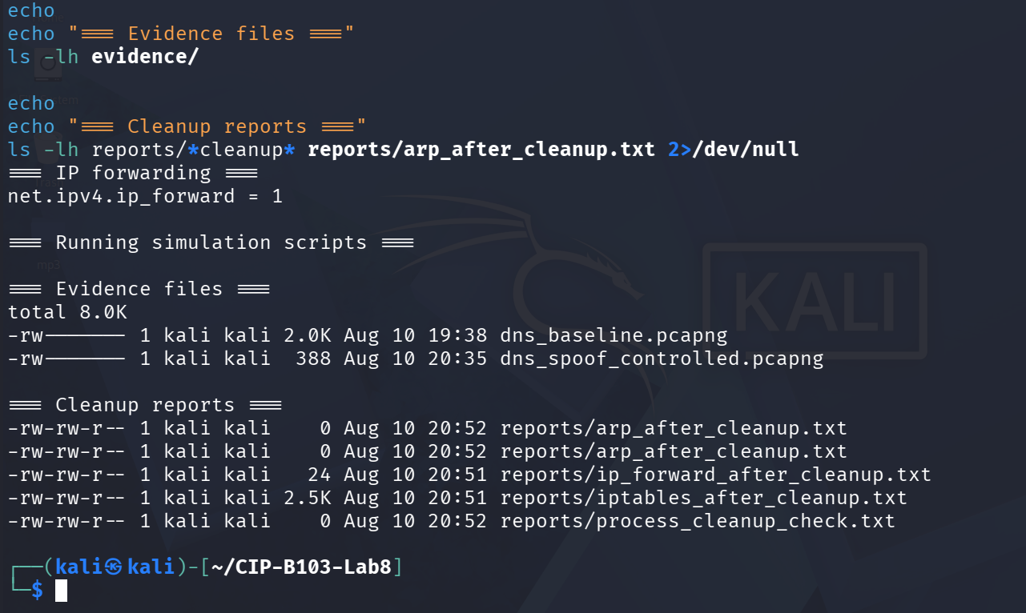
Screenshot 47: Final cleanup verification — IP forwarding, no simulation processes, evidence files and cleanup reports confirmed.

14. Detection and Defensive Recommendations
- Monitor DNS responses from unexpected MAC addresses or hosts.
- Detect multiple answers for the same transaction with conflicting IPs.
- Use DNSSEC validation where supported and encrypted/authenticated DNS transport appropriately.
- Deploy Dynamic ARP Inspection, DHCP snooping, switch port security and network segmentation.
- Use HTTPS certificate validation; a forged DNS answer should not produce a valid certificate for the real service.
- Correlate DNS, ARP, endpoint cache, switch, web proxy and TLS evidence.

Required Screenshots Checklist
☐ Harmless training page and hash.
☐ Baseline ARP table and DNS response.
☐ Reviewed script target/domain settings.
☐ Controlled capture hash.
☐ DNS query and all response records.
☐ Conflicting or forged DNS answer.
☐ ARP claims during event.
☐ Victim HTTP connection to replacement IP.
☐ Baseline-versus-spoof table.
☐ Cleanup, restored ARP and no remaining processes.

Student Report Template
- Executive summary and authorization.
- Lab network diagram.
- Baseline evidence and hashes.
- Controlled simulation method.
- DNS anomaly timeline.
- ARP correlation.
- Victim connection correlation.
- Alternative explanations and confidence level.
- Cleanup and defensive recommendations.
- Appendix.

Submission Requirements
- One PDF report named CIP-B103-Lab8_RegNo_FullName.pdf.
- The original or generated PCAP/PCAPNG evidence file and its SHA-256 hash text file.
- A reports folder containing exported CSV/TXT command output and any recovered objects.
- Screenshots must be readable, numbered and referenced in the report narrative.
- Compress the report and evidence outputs into one ZIP named with your registration number and lab number.
- Do not submit passwords or decoded credentials in public discussion channels; include them only in the protected assessment submission where required.

Marking Rubric (100 Marks)
Assessment Area | Marks | What the Instructor Will Check
Safety and preparation | 20 | Reserved domain, no credential capture, host-only network and baseline recorded.
DNS analysis | 25 | Correct query/response, transaction, responder, answer and TTL analysis.
ARP and connection correlation | 20 | Links DNS anomaly to ARP and subsequent traffic.
Forensic interpretation | 15 | Considers competing explanations and states confidence.
Cleanup and defenses | 10 | Restored environment and appropriate controls.
Report quality | 10 | Professional timeline and screenshots.

Instructor Quick Answer Guide
Checkpoint | Expected Observation
Core indicator | DNS answer points to an unauthorized replacement IP.
Strong packet indicator | Resolver IP appears with an unexpected Ethernet source MAC.
Race indicator | Two conflicting responses share one transaction/query.
ARP correlation | Gateway/victim mapping changes to analyst MAC.
Impact evidence | Victim connects to the forged answer.
HTTPS control | Certificate validation limits successful impersonation of real sites.

Command Reference Summary
Command | Purpose
dns.flags.response | Query/response indicator.
dns.id | Match transaction.
dns.a | IPv4 answer.
dns.resp.ttl | Response TTL.
arp.src.proto_ipv4 / hw_mac | ARP IP-to-MAC claim.
http.host | Requested HTTP host.

Academic Integrity and Authorization Statement
Student Declaration
I confirm that I completed this lab in an authorized environment, preserved the supplied evidence, did not target any third-party system, and accurately documented my own commands, observations and conclusions.

